Jai Deshmukh, Brendan Love

Md. Sarkar

IDP Section 4:00pm

Week 4 Report: Autonomous Tractor, Jai Deshmukh and Brendan Love

1. **Introduction**

For this semester’s Integrated Design Project, the team chose the Autonomous Tractor, a tractor aimed to follow a path drawn out with stripes on the floor. The main objective of the tractor is to autonomously navigate the drawn out strip-map without deviating or obstructing its path. In addition to the main objective, the team hopes to add several special features to the tractor to add functionality and realism.

This week the team worked on planning, certain design tasks, and research for future tasks. The team hopes that this stage will provide us with a solid understanding of our tasks in the future and what the team will need to learn in order to properly complete this project.

1. **Achievements**
   1. Customized Milestones

The team first created a list of long-term and short-term goals the team wanted to achieve. The team did this by customizing each milestone for the autonomous tractor based on our schedules and adding tasks based on different features the team wanted to add. We’ve added our custom milestones below:

Milestone 1:

* Check parts and softwares.
* Practice Python and setup Pygame.
* Create detailed milestone plans and arrange meeting times outside of class.
* Discuss objectives for the autonomous tractor and different methods for movement, sensing, etc.

Milestone 2:

* Develop gyroscope
* Develop ultrasonic sensor and IR sensor.
* Design printed components for mounting components

Milestone 3:

* Setup Bluetooth module and connect to a mobile device.
* Test the tractor to ensure it can follow the path autonomously
* Debug and change code/hardware for any issues.

Milestone 4:

* Design and implement the GUI using Pygame
* Potentially add a trailer and test tractor using the added trailer
* Tune the autonomous program for the newly added trailer
* Add cosmetics using printed parts, if there is time
* Add a battery level indicator to the GUI, if there is time
* Ensure all requirements are functional on the tractor
  1. 3D Schematics

In order to compensate for the lack of space on the tractor frame, Brendan created a frame that could store the breadboard and the arduino along with any other components that needed to be mounted without a designated space on the tractor. The frame, seen in Figure 1, was originally designed to friction fit the hex nuts into the base of the supporting legs, which would then secure the frame to the chassis of the tractor via bolts. In the model, the frame was split into two parts because it was believed that it would not fit on the print bed. Upon slicing the G-Code, the full frame was discovered to fit on the print bed and the split did not interfere with the print. The printed piece did not match the measurements required to fulfill that plan due to the supports being too close together. The solution, rather than spend another nine hours printing the frame, was that the team decided they would glue the frame to the chassis once the main modifications were made, such as drilling holes to affix the L298N. The printed frame has dimensions of 8.25”x4.5”x3.125”. The printed frame is shown in Figure 2.

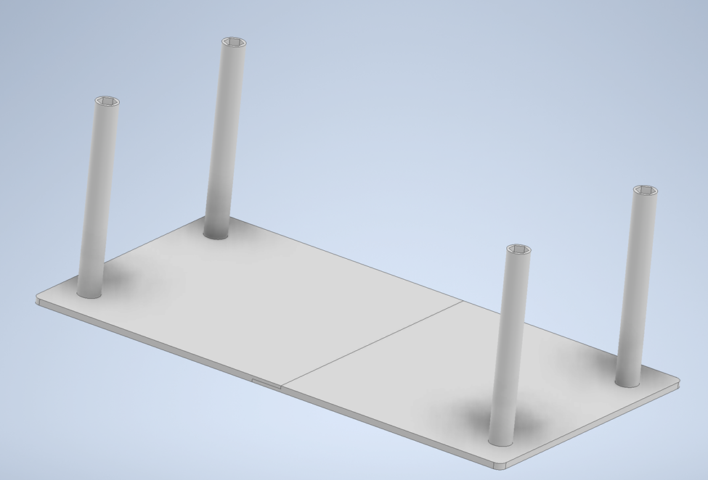

Figure : Model of the extra frame in Inventor

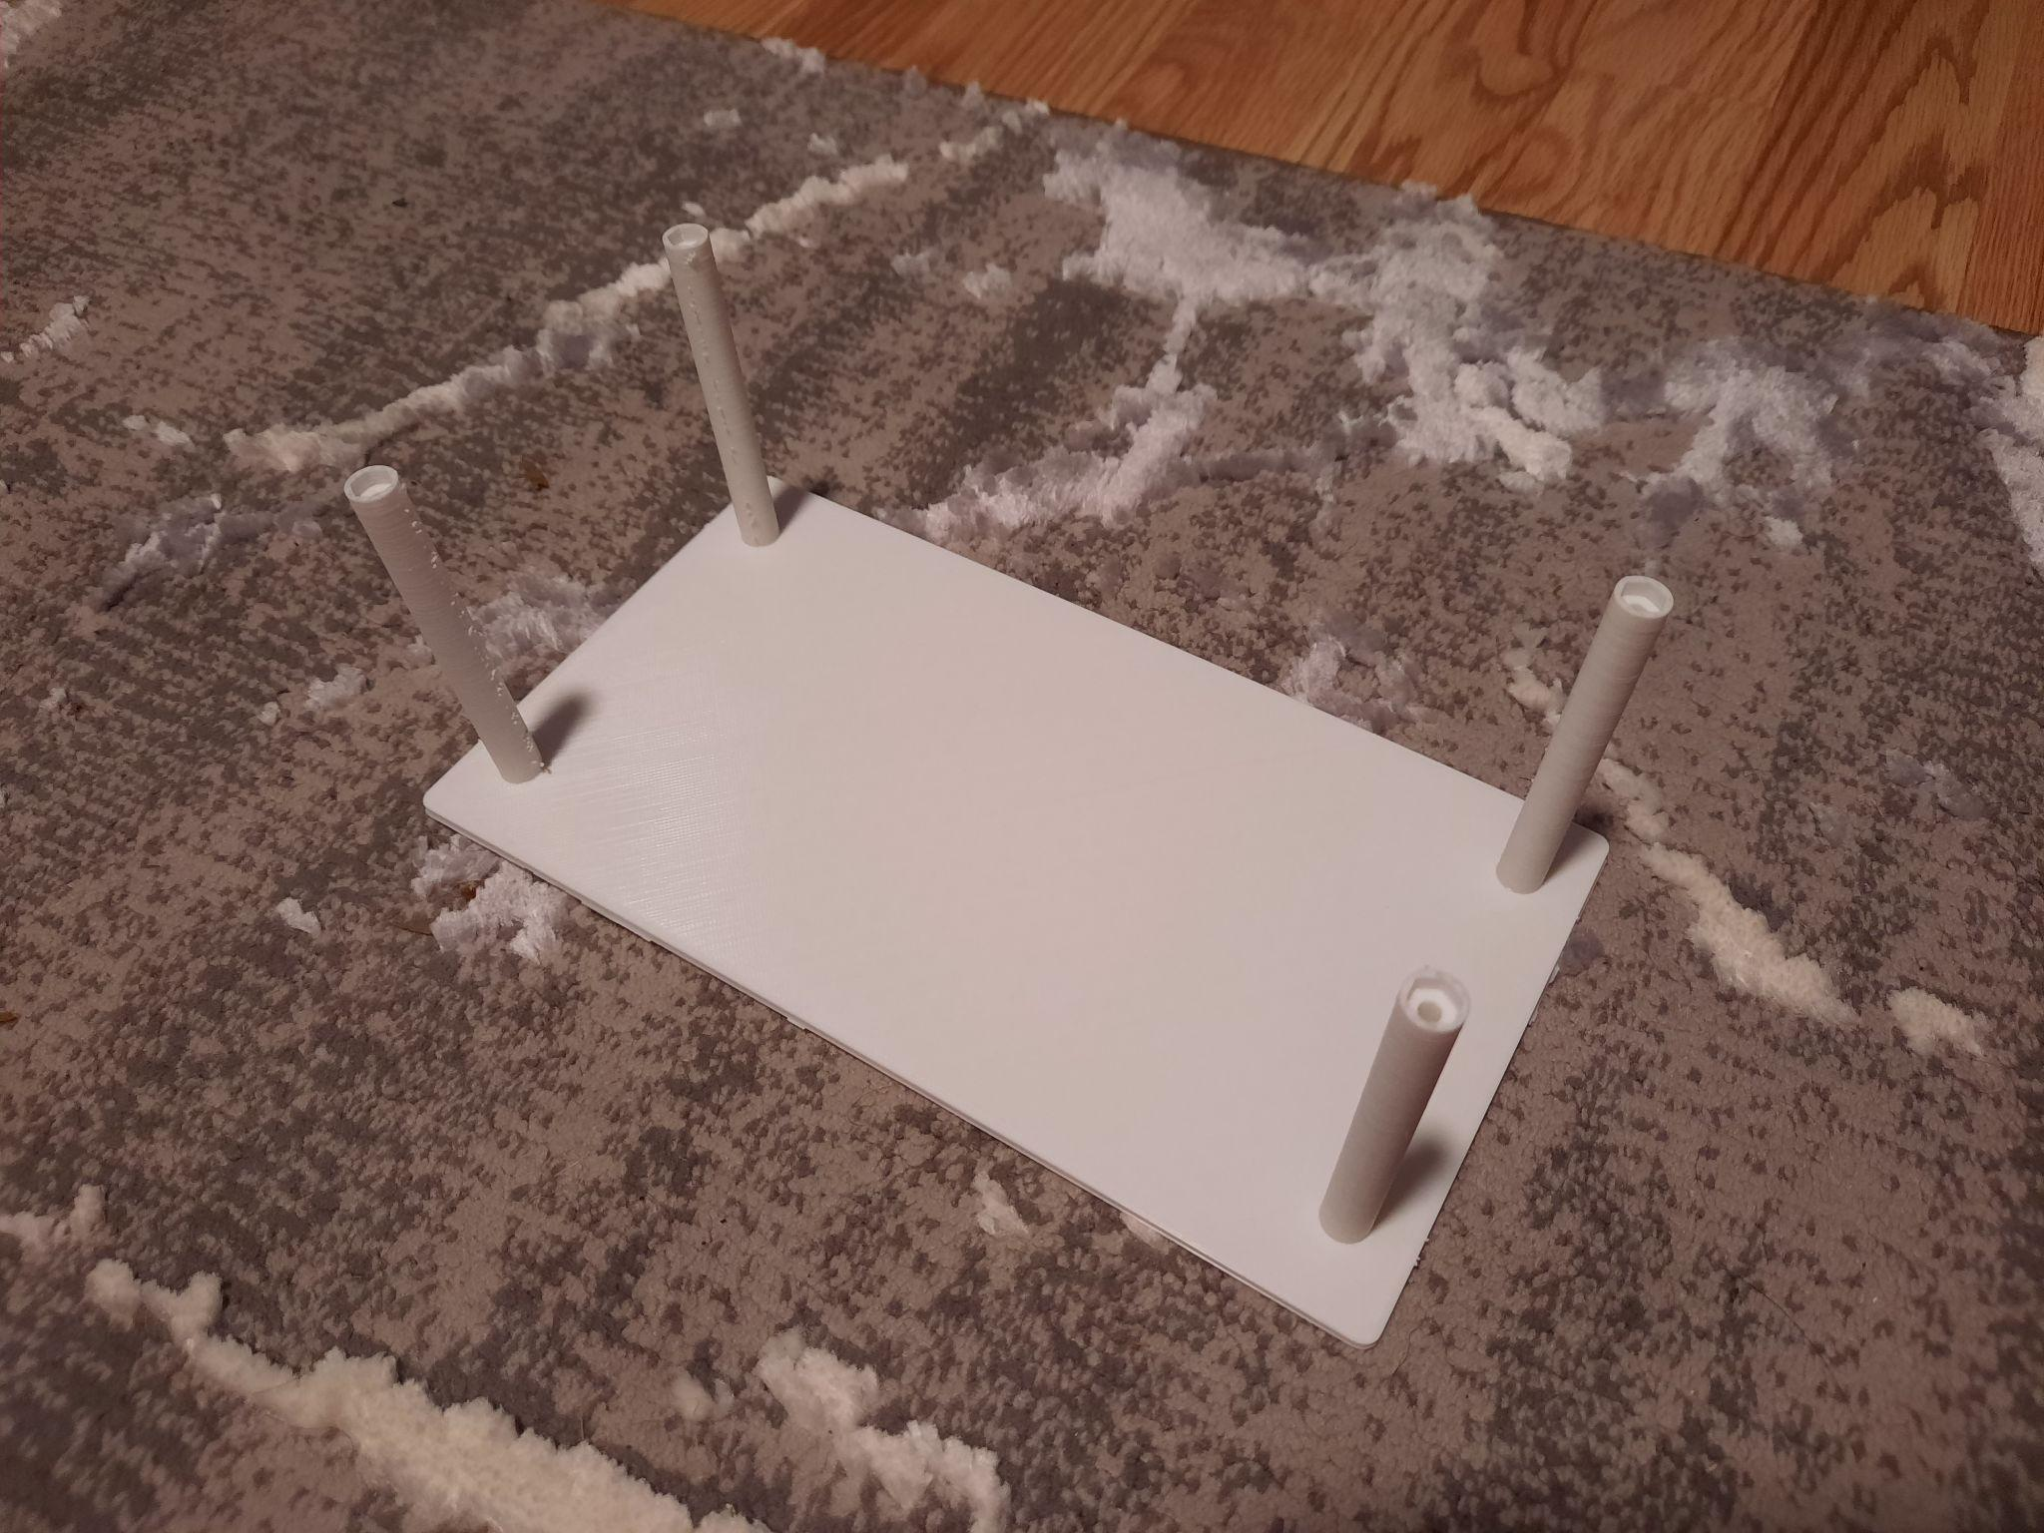

Figure : The printed frame

Brendan also created a sensor mounting module. The sensor mount was made to hold the IR sensor and the ultrasonic sensor. It was decided that these sensors would need to be placed near the front of the vehicle and the large circular cutout was well suited to secure the piece. The model, which can be seen in Figure 3, will snap into the large circular cutout and the IR sensor will be aimed down from inside the circular mount. Inside the circular piece also has a cutout to run wire through so that wire lengths can be kept shorter. There is also a piece that slides into the long cutout on the front of the chassis that will be used for mounting the ultrasonic sensor.

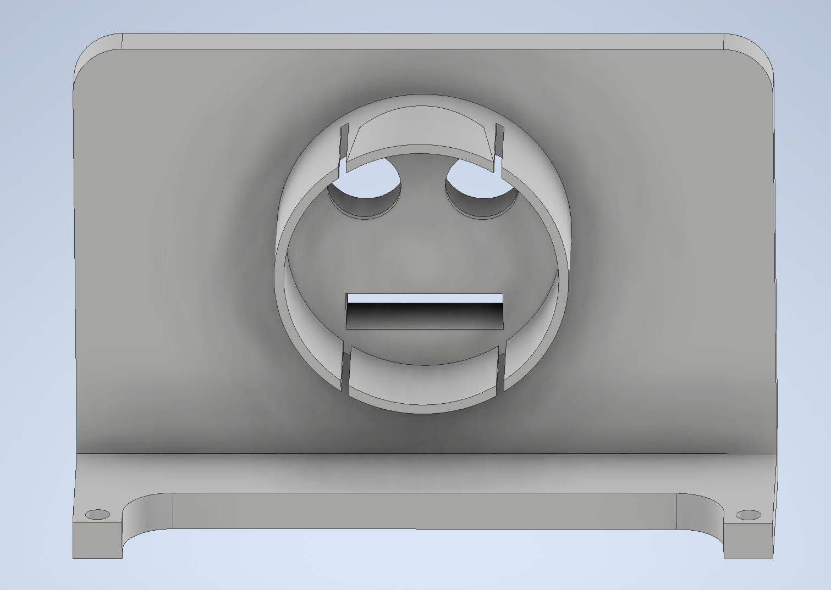

Figure : Model of the sensor mount in Inventor

* 1. Began research on I2C Libraries for Gyroscope

1. **Technical issues**
   1. Path for tractor

One of the main issues the team discovered was understanding the path of the tractor. When the team discussed overall turning mechanisms and how the sensors would understand the path, the team discussed how much space the tractor would have when turning. Based on the given picture the team would only have enough space to make rectangular turns, whereas the team was hoping to make rounded turns to look smoother. The team aims to look for either a physical path that has already been created, or an image of a path created in the past to see how the track will actually be implemented. The team hopes a more realistic form could help us understand the spacing and how dark the guiding lines are for sensor-reading.

1. **Goals for next week**
   1. Gyroscope

The team aims to complete coding a general form of the gyroscope using the current tractor body the team have. The team will use the I2C libraries for the gyroscope and also work on hardwiring the gyroscope onto the tractor body. The team will test the gyroscope’s functionality once the team installs the sensors, as it will allow us to test all components in one testing session.

* 1. Ultrasonic/IR sensor

The team also aims to install the ultrasonic and IR sensors, while focusing less on data collection from the sensors. At this moment, the team wants to focus on hardwiring the sensors to check if they work properly rather than coding the sensors to start detecting. This gives us time to fix the sensors and if needed report if they are non-functional. The team will test the sensors when the team also finishes the gyroscope so the team can test all components in one testing session.

1. **Authorship**

Jai Deshmukh wrote most of this week’s report. Jai wrote the introduction, the technical issues, goals for next week, and most of the customized milestones section.

Brendan Love wrote the 3D Schematics section, helped with the customized milestone section, and proofread the report.